2024 Capital City Cavalier Classic
Hosted Live at Capital City High School
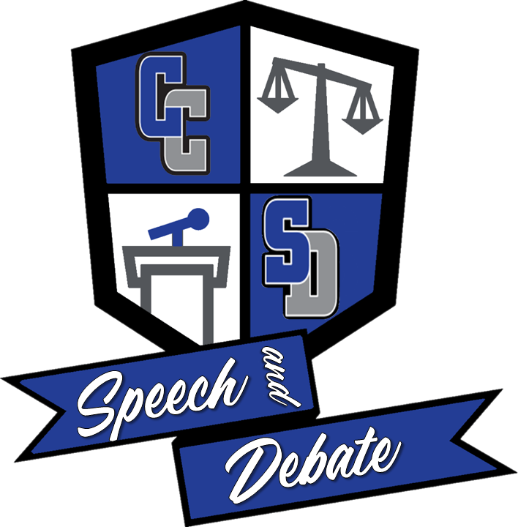
Greetings! The Capital City High School Speech and Debate team cordially invites you to attend the Capital City Cavalier Classic on Friday, January 26 and Saturday, January 27, 2024 to be held at Capital City High School
The Capital City Cavalier Classic boasts a unique tournament experience in the state due to its location, drawing in schools from all over the state to compete. We will be using SpeechWire for this tournament, thus entries should be handled and submitted through the website.
To help our facility managers and to help us accommodate schools, we ask that you please indicate if you are attending by Tuesday, January 9, 2024. To help accommodate these unique entries, teams will be capped at 3 entries per event and division, with additional entries being placed on a waitlist. Waitlisted entries will be granted on a first-come, first-serve basis.
Deadline to submit entries will be Friday, January 19, 2024. Drops need to be completed on SpeechWire by Noon on Tuesday, January 23, 2024. All fees are finalized after this date and time.
Registration will begin at 3:40 pm at Capital City High School. Our school does not dismiss until 3:40 pm, so please pay close attention to arrival details that will be sent out 10 days before the tournament takes place. Expect some traffic trying to get to the school. You will receive special transportation instructions via email, so make sure the email in SpeechWire is your current address.
A hospitality room will be provided for all coaches, judges, and bus drivers. Concessions will be available for all competitors Friday and Saturday.
Aaron Malin, Joe Schneider Head Coach at Capital City HS, Assistant Coach at Capital City HS Mars Finley, Emani Clay Team President, Tournament Director at Capital City HS

Tournament Schedule
Friday, January 26
4:15 pm – Events Round 1 (Draw for Extemp @ 3:45 pm)
5:45 pm – Events Round 2 (Draw for Extemp @ 5:15 pm)
7:00 pm – Debate Round 1
8:30 pm –Debate Round 2
Saturday, January 27
8:00am – Events Semis (Draw for Extemp @ 7:30 am)
9:30am – Debate Round 3
11:00am – Debate Round 4
1:00pm – Events Finals (Draw for Extemp @ 12:30 pm)
2:30pm – Debate Quarterfinals
4:00 pm – Award's Ceremony
5:00 pm – Debate Semifinals
6:30pm – Debate Finals
GLOBAL RULES & ENTRY INFORMATION:
1. A student may enter only two individual events.
2. A student may only enter in one format of debate: Policy, Lincoln Douglas, Public Forum.
3. Entries must be made in SpeechWire with “activated” student accounts. The Host reserves the right to drop any entries that are still without names and/or activation in the week of the tournament so that we are able to appropriately plan the tournament. Advanced notice will be given.
4. We will comply with all MSHSAA rules and regulations regarding the use of electronic devices and the internet. It is a coach’s affirmative duty to ensure their students are aware of the rules and abide by them.
5. In the event MSHSAA does not cover event, NSDA rules will apply.

JUDGING REQUIREMENTS AND EXPECTATIONS
Schools will be obligated to provide judges for rounds based on entry totals.
• 1 judge for every 4 debate entries
• 1 judge for every 5 event entries
Eligible judges include:
• Coaches should mark as much availability as possible. Your MSHSAA-required supervisory
coach will be considered a STANDBY judge for all rounds. It will help us to know who that
coach is and when. Please fill out this COACH FORM let us know who will be on-site and as a
standby judge for each round.
• Community volunteers, parents/guardians, teachers, neighbors, etc....any adult
• Varsity competitors with at least 150 NSDA points
• All judges, including coaches, should sign up using the JUDGE SIGN UP FORM.
Judge expectations:
• We will be using paper ballots.
• Please sign up knowing that you should arrive in your room 15 minutes prior to the start time of
the round. Any rounds you sign up to judge will most likely be assigned to you. Please do not
sign up for a time you cannot be present for. Please mark the times you do sign up for on your
calendar.
• All judge comments should focus on the competitor’s performance in the round - not on their
clothing/attire, if they are masked, etc.

EVENTS
The following events will be offered at this tournament:
Novice Lincoln-Douglas Debate Humorous Interpretation Original Oratory

Novice Public Forum Debate Dramatic Interpretation Informative Speaking

Novice Policy Debate DUO Interpretation Prose/Poetry Interpretation

US Extemp International Extemp Storytelling

Congress

DEADLINES
Entries Due in SpeechWire Friday, January 19 @ 12:00 pm
Waitlisted Entries Evaluated Friday, January 19 @ 4:00 pm
Entry Fees Finalized Tuesday, January 23 @ 4:00 pm

These deadlines will be strictly adhered to in order to ensure the tournament runs on schedule. Please make sure you communicate these deadlines with your students.
ENTRY FEES:
● All single-person events will be assessed $8.00 per entry.
● All partnered events will be assessed $16.00 per entry.
LINCOLN-DOUGLAS, PUBLIC FORUM, and POLICY RULES & PROCEDURES
● All contestants are held to the standard MSHSAA rules for these events.
● Competitors are expected to share any and all evidence read in their rounds if asked by their opponents. Judges may also call for evidence and/or cases. This includes case sharing. ● The official MSHSAA time limit will be followed, including the expanded prep time. ○ Policy: 8 minutes of prep per side
○ Lincoln Douglas: 5 minutes of prep per side
○ Public Forum: 4 minutes of prep per side
● All contestants are expected to keep track of their own prep time.
● Policy and Public Forum Tie Breakers:
○ Win/Loss Record
○ Speaker Ranks
○ Record of Opponent Lost to
○ Total Opposition Record
○ Oppositions’ Opposition Record
● Lincoln Douglas Tie Breakers:
○ Win/Loss Record
○ Record of Opponent Lost to
○ Total Opposition Record
○ Oppositions’ Opposition Record
○ Total Speaker Points
● Rounds 3 and 4 of Debate will be power-matched high-high.
● Brackets will not be broken in Semifinals. Coaches whose teams advance and have to hit each other will be given the option to (a) have their teams debate the round (b) have the higher seed advance
DEBATE TOPICS:
● Lincoln Douglas will use the January/February 2024 NSDA Topic which can be found at www.speechanddebate.org/topics
● Public Forum will use the January 2024 NSDA Topic which can be found at www.speechanddebate.org/topics
● Policy Debate will use the 2023-2024 NFHS/NSDA Topic which can be found at www.speechanddebate.org/topics
United States & International Extemp Rules & Procedures:
● Standard NSDA rules will be used.
● Students will draw three topics and select one to prepare a speech. Students will have 30 minutes of preparation for their topic. No notes may be used during the speech and contestants may not consult with others. Paperless extemporaneous speaking is acceptable under MSHSAA rules.
● Students who are double-entered in extemp should perform extemp FIRST and ask the staff in the draw room to bump the student up.
Original Oratory Rules:
● 10 minutes maximum
● Students will present an original persuasive speech from memory. The speech may not contain more than 150 words of quoted material.
Dramatic and Humorous Interpretation Rules:
● 10 minutes maximum
● Students will present a cutting from a published work of quality literature. The cutting may contain dialogue or may be a monologue, and it must be accompanied by an original introduction. The students must present the piece from memory without the aid of costumes or props. Movement should be minimal.
Duo Interpretation NOT DUET ACTING Rules:
● 10 minutes maximum
● Two-person team of students will perform a memorized selection from a published source of literary merit. An introduction must be provided. Students will use off stage focus. NSDA rules will apply to this event.
Storytelling Rules:
● 8 minutes maximum
● Students must present a published story from memory. The story will be performed from a seated position. An introduction must be provided. No props or costuming is allowed. The intended audience of this event is children.
Prose/Poetry Rules:
● 8 minutes maximum
● Students will present EITHER a selection of prose OR poetry for this competition. At the coaches and student’s discretion, students may choose to perform a prose for one round and poetry the next, and so on, if they choose. Students can use a tablet/e-reader, per MSHSAA rules, or they may use a performance binder. This is a combined event.
Informative Speaking Rules:
● 10 minute maximum
● Students will present an original informative speech from memory. Students present information which the audience may or may not possess and which the students believe is important for the audience – the goal is education, not advocacy. Visual aids are permitted per the NSDA rules.
Program of Oral Interpretation (POI) Rules:
● 10 minute maximum
● Students create a theme or argument through the use of narrative, story, language, and/or characterization. They draw on selections from prose, poetry, and/or drama. Students must use at least two different genres. A manuscript (binder) must be used, and the pieces must be properly introduced.
SWEEPSTAKES
The top two competitors in each event and division will count towards sweepstakes. The top three finishing schools will be recognized.
SPEECH DEBATE
Semifinals 5 pts
Preliminary Win 5 pts
Finals 10 pts
Quarterfinalist 15 pts
Third 5 pts
Second 10 pts
First 15 pts

CAPITAL CLASSIC TOURNAMENT
Capital City High School
ENTRY FORM
Entry fee: $8.00 per entry ($16.00 per team event)
US Extemp _________
International Extemp _________
Original Oratory _________
Humorous Interp _________
Dramatic Interp _________
Duo Interp _________
Prose/Poetry _________
Storytelling _________
Informative _________
Congress ________
Novice Policy Debate _________
Novice Lincoln-Douglas Debate _________
Novice Public Forum Debate _________

*All schools will be allowed THREE entries per event, but may request extras*

